**Starting load testing using jmeter for .net api with entity frame work**

**In first step we add some data min 10 users to check the config. Work properly**

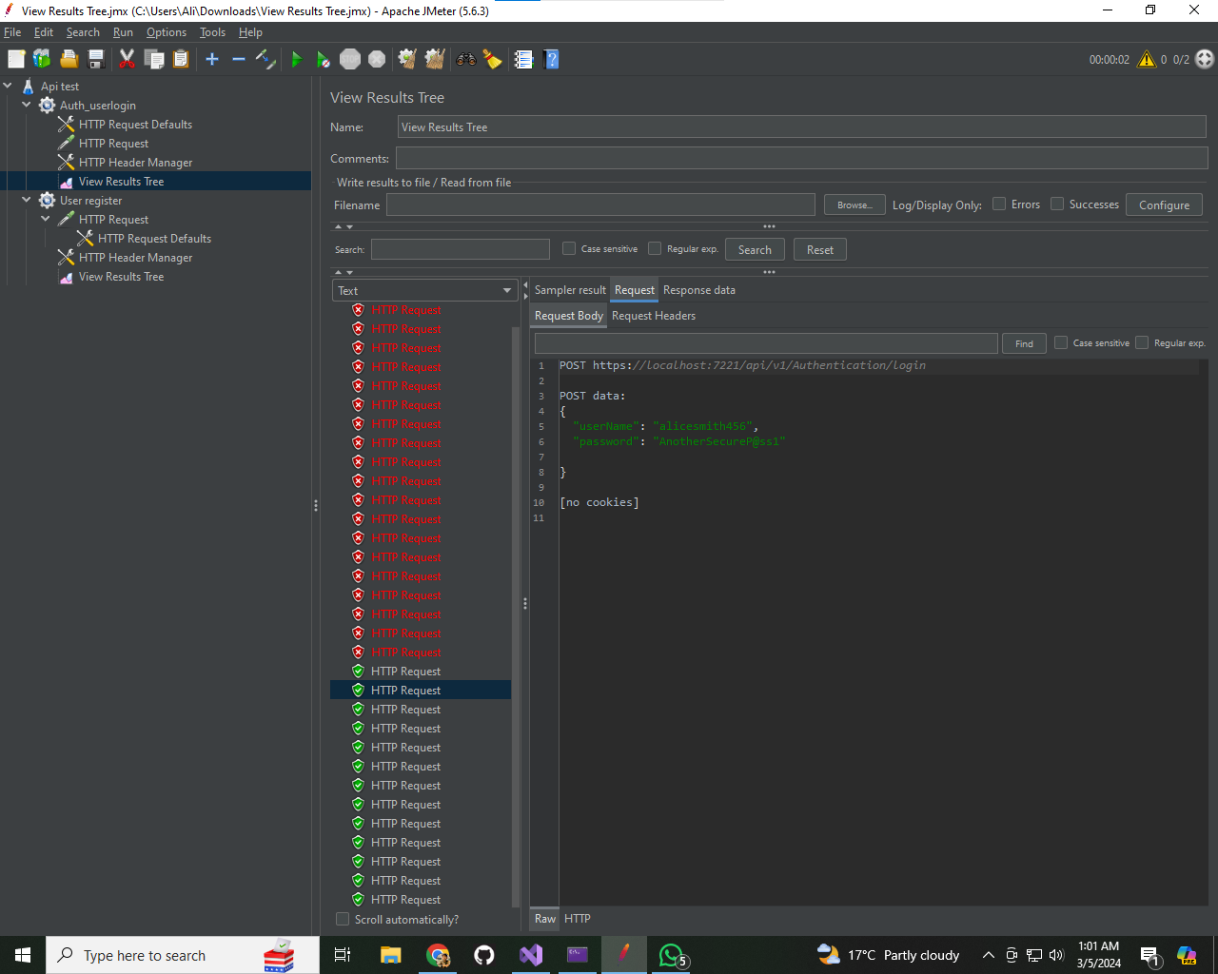

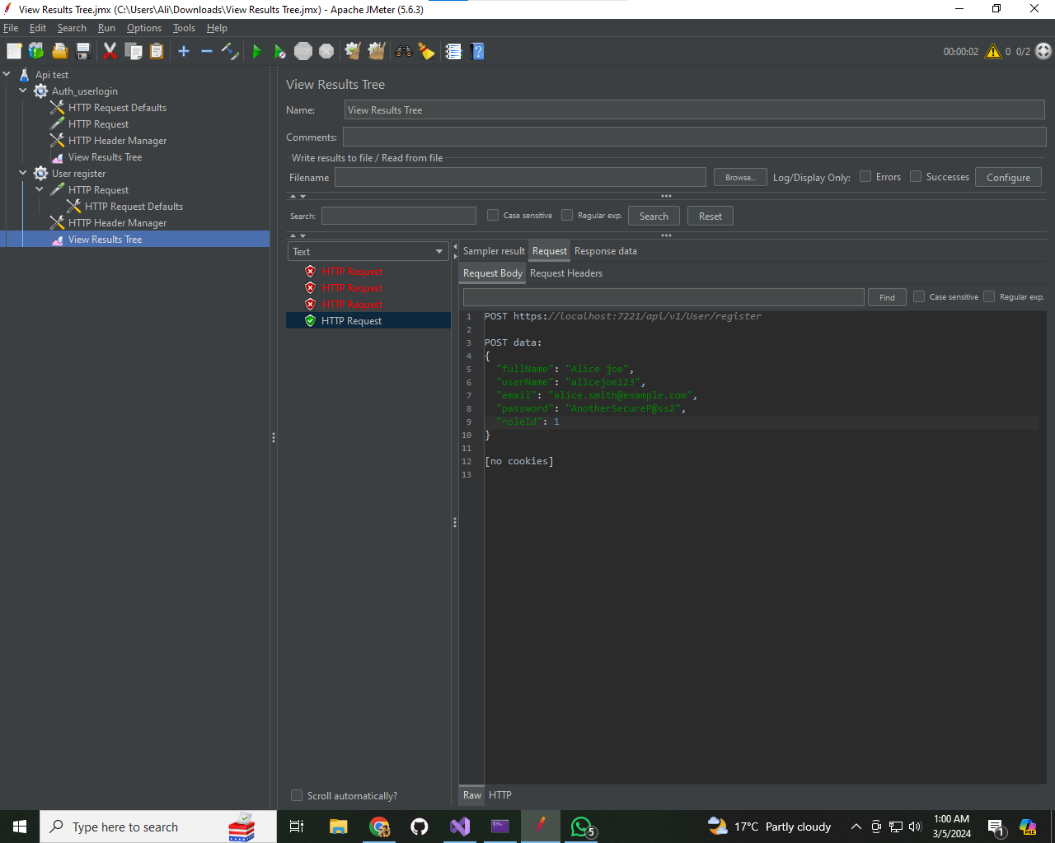

**Now we add different sets of users data.csv file to check the work flow of api**

**Result of load testing**

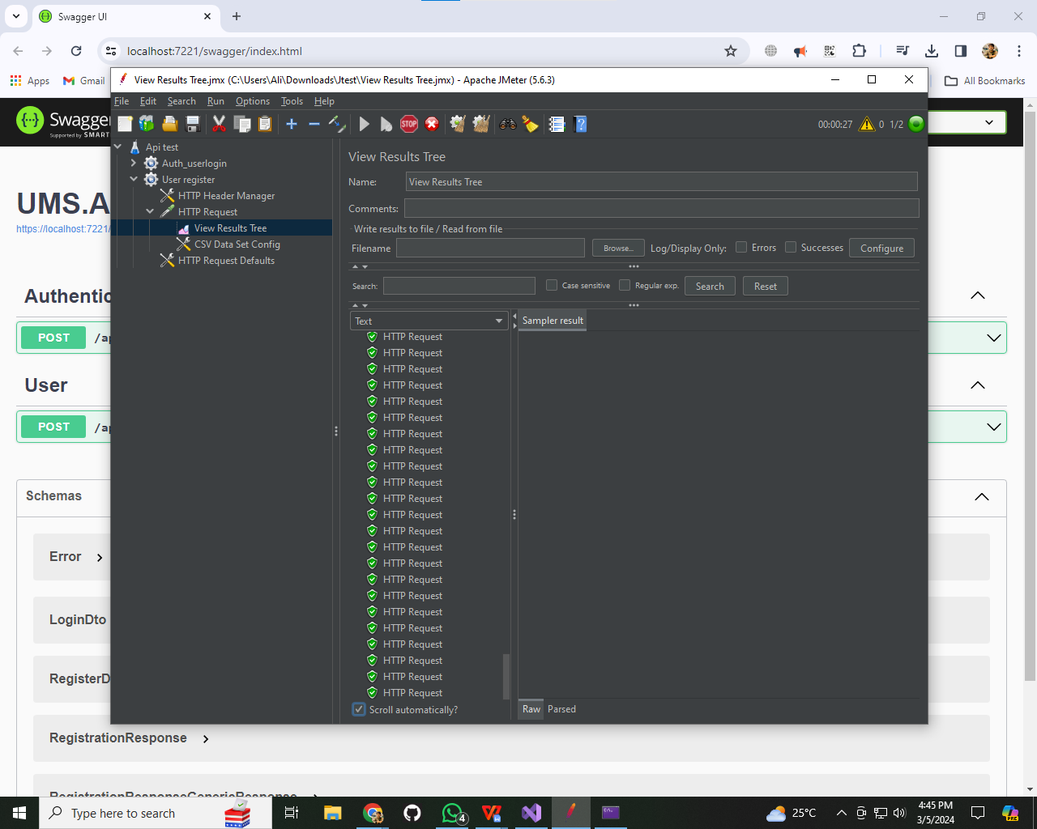The load test results for data.csv users, we need to consider the data provided for two sample HTTP requests: start with 191 milliseconds load time and end with 224 milliseconds load time and returned a response code of 200 (OK), indicating successful responses.

**1. Response Time**

- The response time for the first request was 191 milliseconds, while the response time for the last request was 224 milliseconds.

- This indicates that the response time increased slightly for the second request, possibly due to increased load on the system.

**2. Connect Time**

- Both requests had a connect time of 0 milliseconds, indicating that the connection to the server was established instantly.

**3. Latency**

- The latency for both requests was equal to the load time, indicating that there was no additional delay beyond the time taken to receive the response from the server.

**4. Size of Response**

The size of the response body for the first request was 226 bytes, while for the second request, it was 230 bytes.

This suggests that the size of the response bodies was similar for both requests.

**5. Error Count**

- Both requests had an error count of 0, indicating that there were no errors encountered during the execution of the requests.

**6. Overall Performance**

- With a response code of 200 (OK) and no errors encountered, both requests were successful in processing the user registration.

However, the slightly higher response time for the second request may indicate that the system was under slightly higher load during that specific execution.

**Now we moving forward to Stress test for this purpose we required large dataset we using 20k user data.csv file. To check in stress condition how our api works**

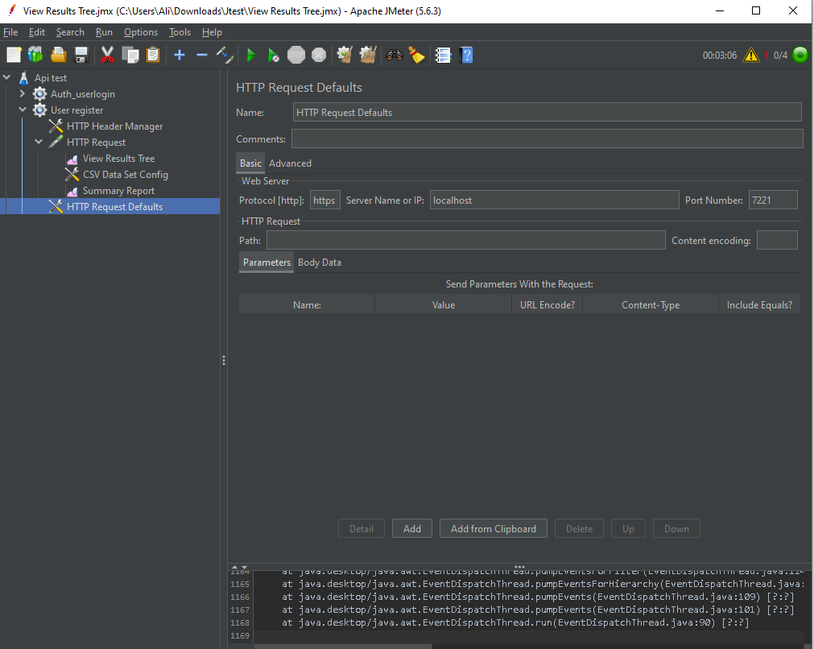**Now again config jmeter for stress test.**

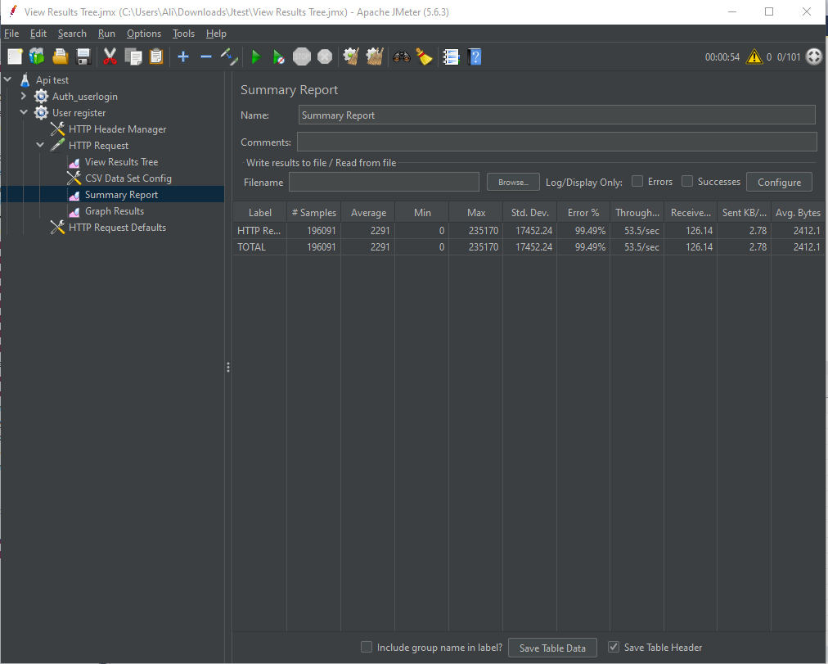

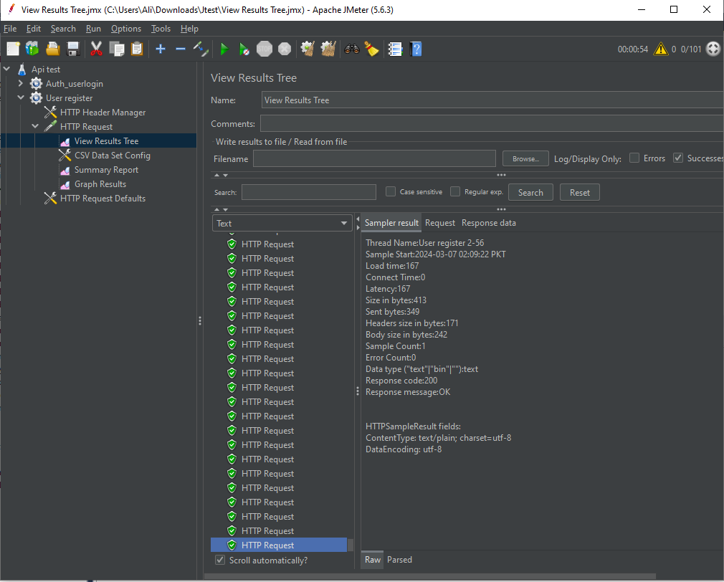**Result of Stress testing**

Summary of the performance metrics for a stress test conducted using JMeter. Let's break down the metrics:

* Total number of requests: 196,091
* Average response time: 22.91 ms
* Min/Max response times: 0 ms / 235,170 ms
* Average throughput: 17,452.24 requests per second
* Error percentage: 0.99%
* 90th percentile response time: 53.55 ms
* 99th percentile response time: 126.14 ms
* Standard deviation: 2.78 ms
* Total time: 2,412.14 seconds (approximately 40 minutes)

According to above result:

The average response time of 22.91 ms indicates that the system responds relatively quickly to requests.

The high throughput of 17,452.24 requests per second suggests that the system can handle a significant load.

The low error percentage of 0.99% indicates that most requests were successful, with only a small fraction resulting in errors.

The 90th and 99th percentile response times (53.55 ms and 126.14 ms, respectively) provide insights into the performance experienced by the majority and a smaller fraction of users, respectively.

The standard deviation of 2.78 ms indicates the variability in response times across different requests.

Overall, these metrics suggest that the system performs well under stress conditions, with fast response times, high throughput, and a low error rate.